**Checking CONTINUE SHOPPING button.**

Step 1: Navigate to swag labs site using the URL - <https://www.saucedemo.com/>

Step 2: Provide valid username and password and click login button. Given: Username= standard_user

Password= secret_sauce

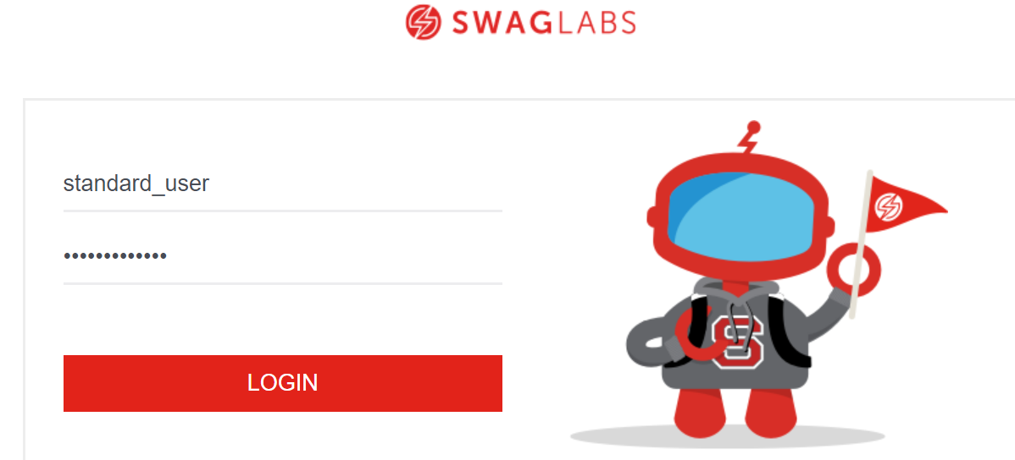

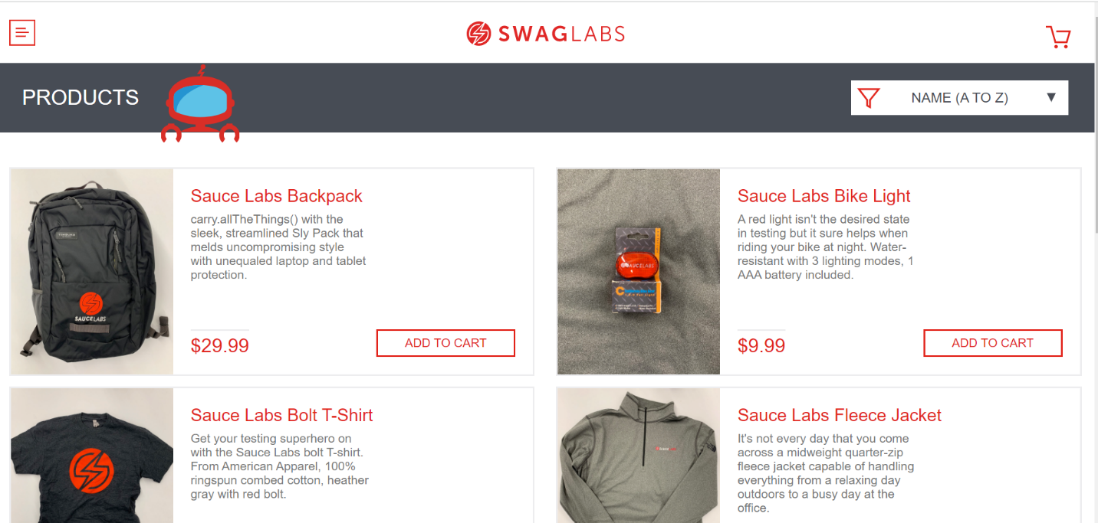

Step 3: Navigate to cart page by clicking cart symbol.

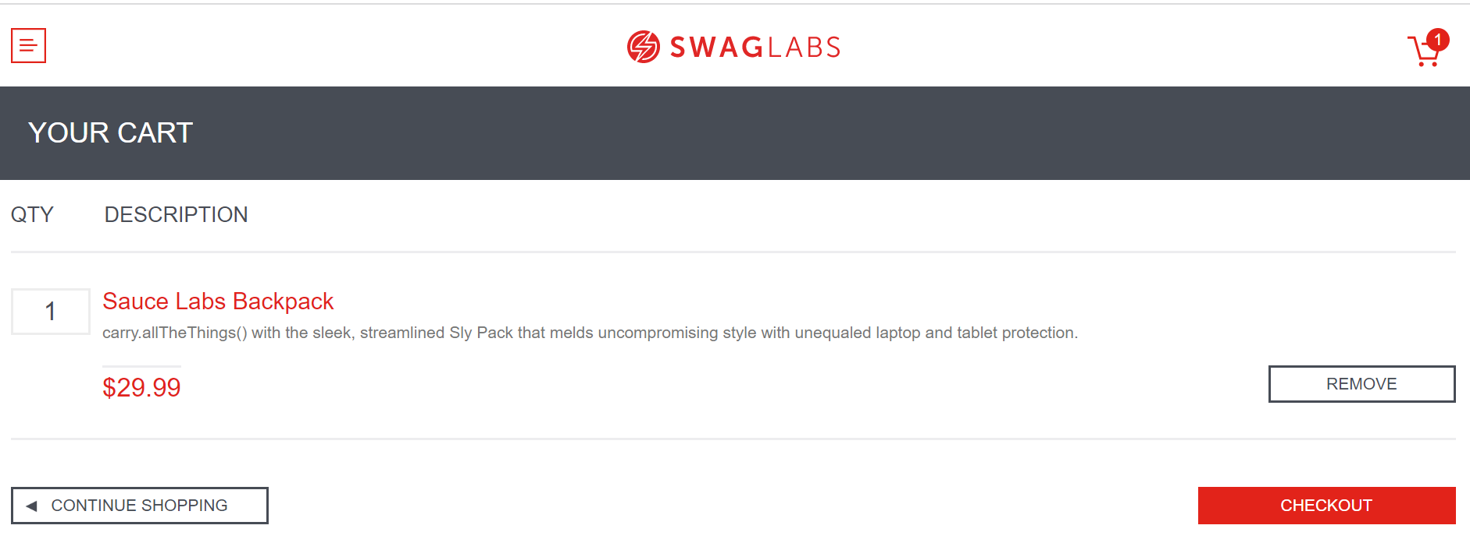

Step 4: By clicking CONTINUE SHOPPING button user should navigate to previous home page.

